Getting Started

GDC 2020-21 Project

This document details everything you need to know to get started working on the project. If a section is not relevant to you right now, skip it!

Contents

**Downloading the Project** **1**

**Project Folders** **2**

# Downloading the Project

*If you’re reading this from a local file in your Unity assets, you’ve already downloaded the project! Feel free to skip this section.*

**Downloading the Project**

1. Download Unity 2020.1.6 [here](https://unity3d.com/get-unity/download). Unity Hub is recommended for managing Unity projects and editor versions, but it is not required. Unity Hub can also be used to install Unity 2020.1.6. On the right-side panel, click **Installs**, click **Add** (top right), then select the latest release.
2. Download GitHub Desktop [here](https://desktop.github.com/). If you do not have a GitHub account, you will need to make one and sign in. In GitHub Desktop, go to **File**🡪 **Clone repository** and select the WVUGDC/fall-2020-r1 repository. Make sure the path is set to wherever you want the project stored on your machine. Make sure you fetch the master branch, but be careful not to push to this branch.
3. Open the project in Unity. If you have Unity Hub installed, navigate to the projects tab and click **Add** (top right). You will need to find the path of the repository, then go down a level into the folder for the Unity project. This folder should be called *WVU GDC 2020-21 Project*. Then open the project. It should look something like what is seen below.

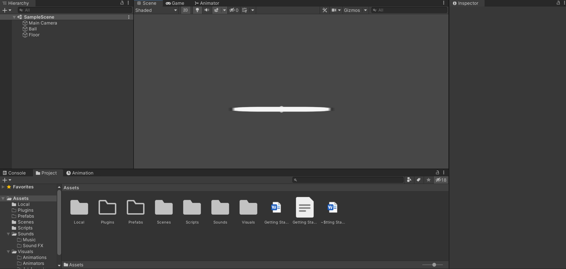

1. Ensure the project runs. First, open the *Sample Scene*. In the project tab on the bottom, navigate to Assets🡪Scenes🡪SampleScene.unity and double click it. In the top center, click the play button (▶️). You should see a ball bouncing around. If so, you’re good to go!

# Project Folders

*This section details what files go in which folders within the Assets folder of the project.*

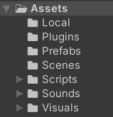

**Unity Assets**

1. **Local:** This folder contains files that you do not want to be uploaded to the repository.
   1. Use this folder for test scripts, temporary assets, and potentially disruptive unfinished assets.
   2. Ensure that nothing outside this folder relies on assets within this folder.
2. **Plugins:** This folder contains all third party plugins and Unity packages.
3. **Prefabs:** This folder contains only prefabs.
   1. Only .prefab and associated meta files should be stored here.
   2. Ensure to categorize assets appropriately into folders.
4. **Scenes:** This folder contains only scene files.
   1. Only .unity and associated meta files should be stored here.
5. **Scripts:** This folder contains only script files.
   1. Only .cs and associated meta files should be stored here.
   2. Ensure to categorize scripts appropriately into folders.
6. **Sounds:** This folder contains all files relating to music and sound FX.
   1. Ensure to categorize assets appropriately into folders.
7. **Visuals:** This folder contains all files relating to visuals, such as sprites, animations, and animators.
   1. Ensure to categorize assets appropriately into folders.